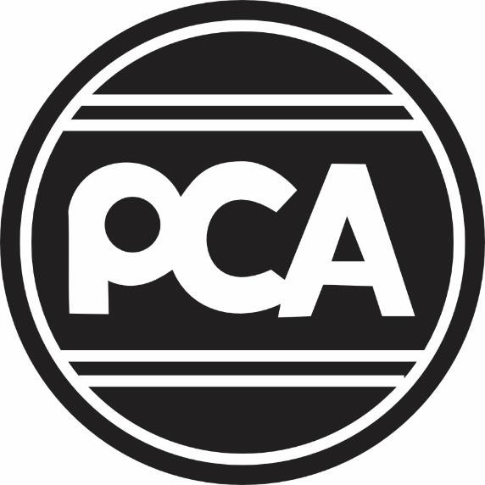

**Request for Proposal**

2025 PCA Golf Tournament

RFP Posting Period: 2/24/2025 thru 03/14/2025

RFP Deadline: March 14, 2025

Committee Final Decision: March 31, 2025

The 2025 PCA Golf Committee requests proposals from interested vendors for the 2025 PCA Golf Tournament.

Proposals must be submitted electronically on or before, March 14, 2025 by 4:00 PM AK Time; submit to Sheri Underwood and Bryan Quinn; [gm@petroclub.net](mailto:gm@petroclub.net) and [bquinn@capital-office.com](mailto:bquinn@capital-office.com)

American ready products due to supply chain concerns are requested.

Bids will be evaluated by quality, creativity, delivery, supplier support and price.

Bids may be awarded to one vendor in full or in part to multiple vendors.

A vendor may submit a proposal for any or all the golf tournament categories listed below. Proposal for each category must include at least the following:

Item description and photo (Vendor to propose – samples may be required prior to selection)

Manufacturer’s Suggested Retail Price (MSRP)

Vendor discount

Shipping cost

Total estimated cost

**All merchandise selected by the golf committee must be delivered to the Petroleum Club Of Anchorage no later than July 9th, 2025.**

**Category 1 - Player Gifts:** Maximum Budget per Player - $140.00 (includes shipping costs)

* Player gifts are distributed to all PCA Golf Tournament players and volunteers. Player gifts should be of premium quality.
* If offering branded apparel, the vendor is responsible for securing sizing from the golfers in advance. Submit the manner in which data mining for sizing will be accomplished in the proposal.
* The Premier Golf Item and Player Golf Item(s) must be delivered fully kitted for distribution.
* Provide/describe any value-added service(s) such as delivery to the golf course at date/time to be provided, personalization, player experience, etc.

1. **2025 Premier Player Golf Item**
   1. Branded player golf item – must be able to host up to 7 – 10 logos: full-color or

one-color imprint is acceptable.

* 1. Quantity 200

1. **2025 Player Golf Item**(s) **/ PCA Logo**
   1. Quantity: 200
   2. Ideally, compliments the Premier Player Golf item

**Category 2 - Golf Awards** – *Refer to Appendix A*

* The committee prefers something unique and utilitarian; plaques not acceptable
* No more than $2,500 including shipping
* Scramble Awards / Stroke Play Awards – Refer to Appendix A for details and quantity
* Premium level Sponsor Awards - Up to 10 | One award per Premium Corporate Sponsor

**Category 3 - Golf Course Hole/Pin Flags** – 18 Holes /co-branded / PCA and Corporate sponsor

**Category 4 - Corporate Sponsorship Signage** – Golf Course and PCA Banquet - *Refer to Appendix B*

**Appendix A**

**Awards**

Player Awards are provided to players who place in the top three in both tournaments, as wells as, other course competitions throughout the day. Sponsorship awards are presented to the Premium Corporate Sponsors. The awards should stand out from other golf tournaments and promotional events and bring an element of class.

**Scramble Awards**

* 1st Place Team, Qty 4
* 2nd Place Team, Qty 4
* 3rd Place Team, Qty 4
* Ladies Long Drive, Qty 1
* Men’s Long Drive, Qty 1
* Ladies Closest to the Pin, Qty 1
* Men’s Closest to the Pin, Qty 1

**Stroke/Medal Play Awards**

* 1st Place, Low Gross, Qty 1
* 1st Place, Low Net, Qty 1
* 2nd Place, Low Gross, Qty 1
* 2nd Place, Low Net, Qty 1
* 3rd Place, Low Gross, Qty 1
* 3rd Place, Low Net, Qty 1
* Club Champion, Qty 1

**Premium Corporate Sponsor Awards** – Up to 10 / Final count will be made available to winning RFP

**Appendix B**

**Signage**

**Golf Course:**

Describe the type of sign(s) recommended for each category. Hardware, if needed, to be supplied by vendor. Signs must be delivered to Moose Run Golf Course 3 days prior to the event. Additional signage may be requested by the Committee, the cost of which will be added to the RFP award if required.

* Qty 18 Hole Sponsor Signs
* Qty 1 Ladies Long Drive
* Qty 1 Men’s Long Drive
* Qty 1 Ladies Closest to the Pin
* Qty 1 Men’s Closest to the Pin
* Qty 1 Driving Range Sponsor
* Qty 1 Putting Green Sponsor
* Qty 1 Welcome Banner/Signage
* Qty 72 Player Golf Cart Signs
* Qty 4 Hole in One Sponsor
* Qty 1 Bag Drop Sponsor
* Qty 2 Courtesy Cart Sponsor
* Qty 2 Beverage Cart Sponsor
* Qty 1 Turn Sponsor
* Qty 1 Breakfast Sponsor
* Qty 1 Mimosa Station
* Qty 1 Bloody Mary Station

**PCA Banquet:**

Provide a recommended sign package and cost based on your vision and ideas to provide an esthetically pleasing environment for attendees and providing maximum exposure for sponsors. Describe the type of sign(s) recommended. Hardware and materials, if needed for installation, are to be supplied by the vendor. Signs must be delivered to the PCA 3 days prior to the event. Vendor to provide assistance to staff and committee members regarding locations for the signage and installation. This may require on-site work by the vendor on the day of and/or the day before the event.